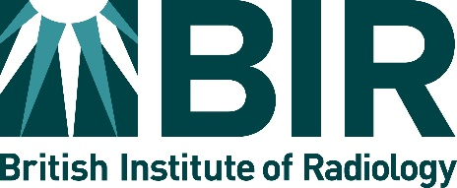

Application for the BIR/MRRA(UK) New Technologies Prize
(Awarded every 2 years)
Details of Applicant(s): Please fill in full details of the lead applicant and provide the names of any other contributors below:
Lead Applicant:
Title and Surname:
Other Names:
Email Address:
Current Post:
Name of Employer/Training Scheme/Hospital:
Address:
City: | Postcode:
Relevant Publications:

Other Contributors:
Name:
Name:
Name:
Name:

Details of the technological development or clinical application of the new technology:

Summary: (no more than 200 words)

Describe the impact of the development, including the impact on patient care, If applicable.

Provide evidence of the impact of your development:

Provide evidence of the originality/novelty of your work:

Signature by applicant: ……………………………………………………………Date…………………………………………………

Please email completed form and any relevant supporting attachments to: awards@bir.org.uk
Or post to: Mrs Lucy Stewart, BIR, Audrey House, 16-20 Ely Place, London EC1N 6SN
Closing date for applications: 31 May 2026

