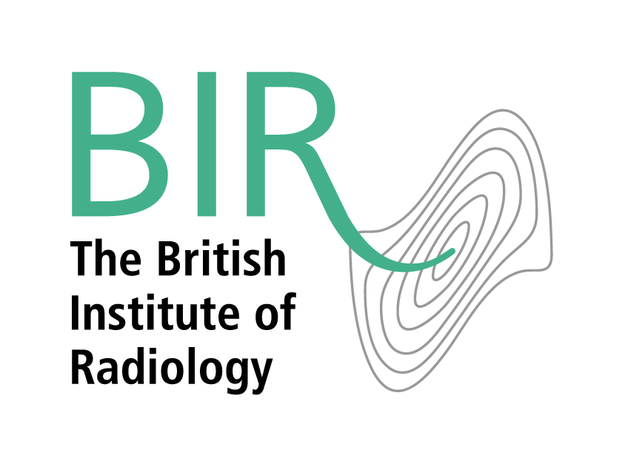

**Complaints procedure**

We are committed to providing a high-quality service to all members, customers and users of our services. When something goes wrong, we need you to tell us about it. This will help us to improve our standards.

If you have a complaint, please contact us with the details. We aim to respond to all complaints within one week, and to resolve the complaint within eight weeks.

**What will happen next?**

1. We will acknowledge receipt of your complaint within one week of receiving it, and provide you with a copy of this procedure. We will also notify you of the person within the BIR who is responsible for reviewing your complaint and communicating the results to you.
2. We will then investigate your complaint. This will normally involve passing your complaint to a senior member of the BIR staff, who will review your matter. If appropriate, we will consult relevant non-staff members if they were involved in the matter under complaint, or have relevant responsibilities. These might, for instance, include Trustees, Special Interest Group management group members, branch management group members, Editors, meeting organisers or speakers. We may also consult suppliers. If the matter requires professional expertise or knowledge of an industry, sector, or technical field, we may consult a relevant expert. For complaints involving articles published in one of our journals we will follow the guidance of COPE (Committee on Publications Ethics).
3. We will normally resolve complaints by email or by telephone. If appropriate, we may request a meeting with you.
4. Once we have investigated your complaint we will inform you of the results and if appropriate, we will discuss with you the best way to resolve the matter
5. At this stage, if you are still not satisfied, you should contact us again and we will arrange for the matter to be escalated to a more senior person within the BIR.

**Complaints about members and third parties**

The BIR does not have regulatory authority or have an adjudicating role, and is not normally the appropriate organisation to consider complaints about members, corporate members, sponsors, partners or suppliers unless the complaint is about their conduct as representatives of the BIR.

If your complaint is about the conduct of a member, corporate member, sponsor, partner or supplier in their capacity as a representative of the BIR, then the process outlined above will apply.

If you believe the member, corporate member, sponsor, partner or supplier has acted unlawfully or unethically then we recommend that you make a complaint to the relevant company or organisation, or to the relevant legal or regulatory body.

**Anonymous complaints**

We are not normally able to deal with complaints from anonymous sources or sources communicating with us using a pseudonym, unless there are clear and reasonable reasons to do so. You will be asked to provide us with your name, contact details, and place of work, and we reserve the right to discontinue the complaints process if these are not forthcoming. We reserve the right to investigate that you have provided us with accurate contact details and in the case of complaints against third parties, what your relationship has been with that third party.