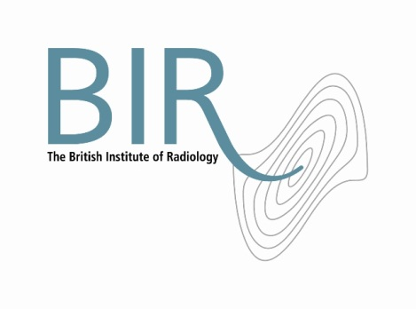

4 April 2018

**Israel Radiological Society joins British Institute of Radiology (BIR) scheme to share knowledge of imaging and radiation oncology worldwide**

The Israel Radiological Society has joined with the BIR and other societies around the world in a new initiative: the BIR World Partner Network. This is a community of international societies with the shared goal of advancing the knowledge and understanding of imaging and radiation oncology amongst radiologists, radiographers and physicists across the world.

Participating societies are the Sociedad Argentina de Radiología, Federacion Argentina de Radiologia, Australian Society of Medical Imaging and Radiation Therapy, Brazilian College of Radiology and Diagnostic Imaging, Canadian Association of Medical Radiation Technologists, Chinese Society of Radiology, Chinese Taipei Society of Radiology, German Röntgen Society, Hong Kong College of Radiologists, Indian Radiological and Imaging Association, International Society of Radiographers and Radiological Technologists, Israel Radiological Society, Japanese Radiological Society, Russian Society of Radiology, Spanish Radiological Society and the Radiological Society of South Africa.

The members of each society will receive regular online content that can be easily accessed by participants from devices worldwide. Examples include papers from BJR, the BIR’s flagship journal, webinars featuring the world’s leading practitioners and video content by global experts. These resources will be shared through newsletters and intranets to individual society members.

Professor Jacob Sosna, President of the Israel Radiological Society said “International collaboration is of immense importance for the advancement of science in general and our profession in particular.”

Andy Rogers, BIR President said “We are delighted to be able to join with Israel Radiological Society and other leading societies from around the world to share knowledge and expertise. Ultimately this will benefit patients everywhere.”

For further information please contact Carole Cross, Head of Membership & Communications [carole.cross@bir.org.uk](mailto:carole.cross@bir.org.uk) or call 020 3668 2224.

Ends

Image:

Left to right

Professor Jacob Sosna (President of The Israel Radiological Society) and Andy Rogers (President, BIR).

**Notes to Editors**

**About The British Institute of Radiology**

The British Institute of Radiology is an international membership organisation for everyone working in imaging, radiation oncology and the underlying sciences.

Our aims are to:

•               support the work of our members and their colleagues to achieve professional excellence

•               provide continuing professional development for our multidisciplinary community

•               publish cutting-edge research for our authors and readers across the world

•               influence and connect with the wider professional sector.

Registered Charity No: 215869

**For information about this release please contact:**

Carole Cross

Communications Manager

48-50 St John Street

London EC1M 4DG

Tel. 020 3668 2224 [carole.cross@bir.org.uk](mailto:carole.cross@bir.org.uk) [www.bir.org.uk](http://www.bir.org.uk)

Mobile 07963 200147 (out of office hours)

<https://www.facebook.com/thebritishinstituteofradiology>

<https://twitter.com/BIR_News>