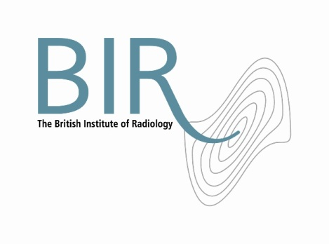

6 February 2018

**The British Institute of Radiology launches new open access journal**

The British Institute of Radiology (BIR), the multidisciplinary membership society and publisher, is delighted to announce the launch of a new international, fully open access, online journal to be published alongside their growing collection of titles. [*BJR|Open*](http://www.birpublications.org/bjro)will join [*BJR*](http://www.birpublications.org/bjr)and *[BJR|case reports](http://www.birpublications.org/bjrcr)*, publishing papers across the whole of the radiological sciences, including radiology, radiation oncology, radiobiology, medical physics, nuclear medicine and all allied areas.

Professor Katja Pinker, Professor of Radiology at Memorial Sloan Kettering Cancer Center, New York, USA and Professor Habib Zaidi, Chief Physicist at Geneva University Hospital, Switzerland are *BJR|Open*’s founding Editors-in-Chief.

The journal will be overseen by an expert international Editorial Board and will benefit from the same rigorous, double blind peer review undertaken by all BIR journals. With the added benefit of being fully open access, all articles will be free to read for all and receive high visibility.

*BJR|Open* will open for submissions later in 2018.

Professor Zaidi described the journal as, “a fantastic home for high quality research, offering authors the opportunity to disseminate their work widely amongst the radiology community.”

Professor Pinker added, “I am delighted to be involved in the development of this new journal. I think it is a really exciting time for the field of radiology, with new methods and technologies emerging, and we aim to reflect this and publish high quality research from across our multidisciplinary community. ”

Sophia Anderton, Head of Publishing at the BIR said, “More and more authors are required to or are choosing to publish their work via open access. The launch of *BJR|Open* creates a home at the BIR for authors who want to publish in a wholly open access journal. We are very excited about the launch of this journal and expanding our offerings for the radiology community”.

Read more about the journal at [birpublications.org/bjro](http://www.birpublications.org/bjro).

Ends

**Notes to Editors**

**About The British Institute of Radiology**

The British Institute of Radiology is an international membership organisation for everyone working in imaging, radiation oncology and the underlying sciences.

Our aims are to:

•               support the work of our members and their colleagues to achieve professional excellence

•               provide continuing professional development for our multidisciplinary community

•               publish cutting-edge research for our authors and readers across the world

•               influence and connect with the wider professional sector.

Registered Charity No: 215869

**For information about this release please contact:**

Carole Cross

Communications Manager

48-50 St John Street

London EC1M 4DG

Tel. 020 3668 2224 [carole.cross@bir.org.uk](mailto:carole.cross@bir.org.uk) [www.bir.org.uk](http://www.bir.org.uk)

Mobile 07963 200147 (out of office hours)

<https://www.facebook.com/thebritishinstituteofradiology>

<https://twitter.com/BIR_News>