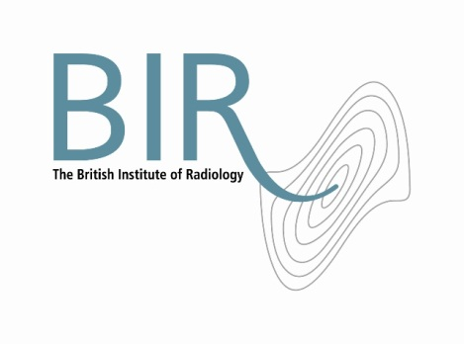

5 October 2017

**BIR** **/GE Radiation Safety Award 2017**

Mark Worrall, Radiation Protection Adviser, from Ninewells Hospital, Dundee, has won the first BIR/GE Radiation Safety Award. The prize offers a bursary to enable the recipient to present their work on radiation safety in healthcare at a scientific conference of their choice.

Mark will present his work on the creation of a computational model to accurately estimate the thickness of an attenuator from a single digital radiograph at the *International Conference on Radiation Protection in Medicine: Achieving Change in Practice* in December in Vienna. The award of £1,000 and a certificate was presented on 26 September 2017 at the “New Ionising Regulations” event in London by Simon Hemsworth, Marketing Manager, Northern Europe (GE Healthcare), Andy Rogers, BIR President and Dawn Philips, Sales and Marketing Leader (GE Healthcare).

Simon Hemsworth, said ““GE Healthcare is committed to supporting healthcare providers in imaging radiation safety and we are proud to sponsor this award for the next 4 years. Congratulations to Mark on winning the inaugural award!”

Andy Rogers, BIR President, said “Congratulations to Mark and thank you to GE Healthcare for supporting this award which encourages people to think innovatively about improving radiation safety in healthcare worldwide. Mark’s research has the potential to positively impact on practice especially in the area of paediatric patient dose studies.”

The award is presented every two years. For more information and how to enter the 2019 award visit <http://www.bir.org.uk/radiationsafetyaward>

Photograph: Left to right: Simon Hemsworth, Marketing Manager, Northern Europe (GE Healthcare), Mark Worrall, Andy Rogers, BIR President and Dawn Philips, Sales and Marketing Leader (GE Healthcare).

**Ends**

**Notes to Editors**

**About The British Institute of Radiology**

* The British Institute of Radiology (BIR) is an independent multidisciplinary organisation, and a registered charity, whose membership is open to everyone with an interest in radiology and radiation oncology.
* The British Institute of Radiology is the oldest radiological society in the world.
* We strive to ensure that the potential of image science and radiation technology to prevent, detect and combat disease is fully realised. We believe in the importance of research and education, and we promote collaboration and the sharing of knowledge and understanding.
* To help fulfil our aims, we undertake a wide range of activities, including publishing, the organisation of scientific meetings and conferences and the provision of library and information services.

Registered Charity No: 215869

**For information about this release please contact:**

Carole Cross

Communications Manager

48-50 St John Street

London EC1M 4DG

Tel. 020 3668 2224 [carole.cross@bir.org.uk](mailto:carole.cross@bir.org.uk) [www.bir.org.uk](http://www.bir.org.uk)

Mobile 07963 200147 (out of office hours)

<https://www.facebook.com/thebritishinstituteofradiology>

<https://twitter.com/BIR_News>