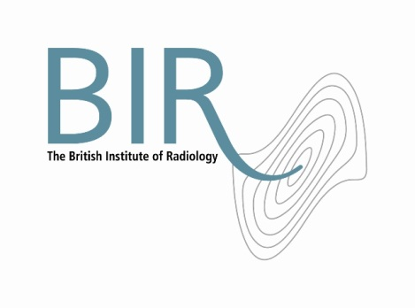

1 September 2017

**Barcojoins the British Institute of Radiology**

Barco has joined the British Institute of Radiology (BIR) as a corporate member. Corporate members are part of the BIR community and collaborate in developing educational events and publishing activities, as well as being an important source of education and expertise for the BIR.

Barco, a global leader in healthcare imaging, specialises in high quality medical displays systems including specific product lines for mammography, radiology, and dentistry.

Simon Thompson, Chief Executive of the BIR said: “We are delighted to welcome Barco to the BIR. Our community looks forward to understanding more about the advances in medical displays and how it can support the professions in imaging and radiation oncology.”

Piet Candeel, Senior Vice President at Barco, said: “Just like the BIR, Barco is on a constant quest to help radiologists diagnose illnesses as efficiently, accurately and confidently as possible – in order to enable the best healthcare outcomes. The BIR is a powerful platform for us to connect to radiologists and understand their needs. At the same time, we will be happy to share our imaging insights with the radiology community.”

Ends

Photo: (left to right) Simon Thompson, BIR Chief Executive, Michelle Dimmock, Manager, Channel Development And Strategic Programs EMEA Healthcare and Sarah Suraiyya, Business Development Consultant UK&I

**Notes to Editors**

**About The British Institute of Radiology**

The British Institute of Radiology is an international membership organisation for everyone working in imaging, radiation oncology and the underlying sciences.

Our aims are to:

•               support the work of our members and their colleagues to achieve professional excellence

•               provide continuing professional development for our multidisciplinary community

•               publish cutting-edge research for our authors and readers across the world

•               influence and connect with the wider professional sector.

Registered Charity No: 215869

<https://www.facebook.com/thebritishinstituteofradiology>

<https://twitter.com/BIR_News>

**About Barco**

Barco, a global technology company, designs and develops networked visualization products for the Entertainment, Enterprise and Healthcare markets. Barco (NYSE Euronext Brussels: BAR) is active in more than 90 countries with 3,500 employees worldwide. Barco co-creates technology solutions for integrated care throughout the hospital enterprise.

Barco develops medical displays systems including specific product lines for mammography, radiology, dentistry and a line of clinical review displays, which supports physicians and healthcare professional’s with consistent calibrated, quality-controlled medical images minimizing clinical errors. Barco’s solutions for the Integrated OR, Hybrid OR and Interventional Suite combine leading-edge surgical display technology, seamlessly integrated with our Nexxis video-over-IP technology, for the best precision, efficiency, and flexibility.

**For information about this release please contact:**

Carole Cross

Communications Manager

48-50 St John Street

London EC1M 4DG

Tel. 020 3668 2224 [carole.cross@bir.org.uk](mailto:carole.cross@bir.org.uk) [www.bir.org.uk](http://www.bir.org.uk)

Mobile 07963 200147 (out of office hours)

<https://www.facebook.com/thebritishinstituteofradiology>

<https://twitter.com/BIR_News>