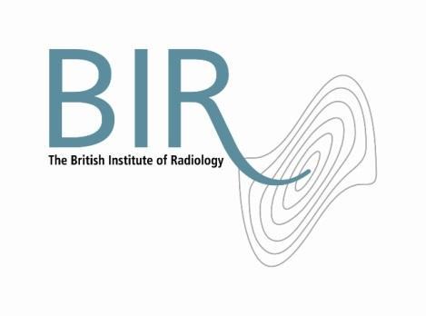

21 June 2017

**Veritekjoins the British Institute of Radiology**

The British Institute of Radiology (BIR) is delighted to welcome Veritek as a corporate member.

BIR corporate members are encouraged to join the BIR community and to collaborate in educational developments and to get involved with publishing activities.

Veritek is a leading provider of whole-life maintenance services for complex medical imaging equipment across Europe. Veritek is a technical service business, not affiliated with manufacturers.

Simon Thompson, Chief Executive BIR said “Veritek is the first company of its kind to join the BIR. We look forward to working with them, finding out about best practice in service and maintenance and introducing them to the BIR community.”

Jim Edgar, Veritek CEO said “Veritek is delighted to have joined the BIR and we look forward to collaborating fully. We seek to expand and deepen our healthcare related maintenance and support activities in the UK and across Europe. Being part of the BIR will be an important step on this journey”

Photo: (left to right) Simon Thompson (BIR Chief Executive) and Jim Edgar (CEO Veritek).

Ends

**Notes to Editors**

**About The British Institute of Radiology**

The British Institute of Radiology is an international membership organisation for everyone working in imaging, radiation oncology and the underlying sciences.

Our aims are to:

•               support the work of our members and their colleagues to achieve professional excellence

•               provide continuing professional development for our multidisciplinary community

•               publish cutting-edge research for our authors and readers across the world

•               influence and connect with the wider professional sector.

Registered Charity No: 215869

<https://www.facebook.com/thebritishinstituteofradiology>

<https://twitter.com/BIR_News>

**About Veritek**

Veritek was founded in 1986 and has its headquarters in Polegate, East Sussex UK.

Initially Veritek was a family-run, UK-focused provider of photo equipment servicing. Over the 31 years since it was founded, the business has transformed into a leading provider of whole-life maintenance services for complex equipment in multiple sectors across Europe.

Veritek acts for multiple manufacturers and end users in all of the markets in which we operate. Almost all of the tens of thousands of pieces of equipment that Veritek look after are imaging or print related.

**For information about this release please contact:**

Carole Cross

Communications Manager

48-50 St John Street

London EC1M 4DG

Tel. 020 3668 2224    [carole.cross@bir.org.uk](mailto:carole.cross@bir.org.uk)  [www.bir.org.uk](http://www.bir.org.uk)

Mobile 07963 200147 (out of office hours)

<https://www.facebook.com/thebritishinstituteofradiology>

<https://twitter.com/BIR_News>