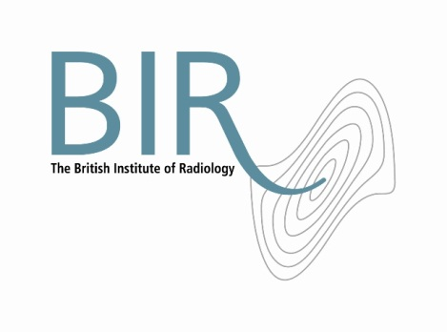

22 May 2017

**BIR STATEMENT**

**Thank you to radiology departments during NHS cyber attack**

The BIR applauds radiology and oncology teams who were faced with unprecedented challenges during the recent ransomware attack on NHS trusts across the UK. PACS teams, radiologists, radiographers, registrars and I.T. teams worked through the nights and weekend to begin isolating damage, restoring systems and ensuring the safety of patients was not compromised.

Alexander Peck, Communications Lead for the BIR Clinical Intelligence and Informatics Special Interest Group and Chartered I.T. Professional said “*As the threat began to hit hospital after hospital throughout Friday morning, Radiology Managers and Clinical Directors had to make tough decisions in a short space of time. Whilst this attack affected each hospital individually, in many cases those who acted quickly, closing non-acute services to concentrate resources and swiftly disconnecting modalities from infected networks, suffered the least damage. An approach of isolation meant minimal short-term disruption whilst defences were put in place to detect, contain and eliminate the malware.”*

*“Many in the wider media have asked why the NHS was so vulnerable. In reality it is simply not possible to constantly change or update software in the environments these systems operate in. High quality digital diagnostic equipment is now fully integrated into the hospital environment and is a key part of the clinical decision making process. As a result, the discussion on future prevention strategies is a top priority for PACS Teams and I.T. Departments.”*

Andy Rogers, President of the BIR, said “Hats off and a huge thank you to radiology teams, IT staff across the UK who worked ceaselessly to tackle this massive challenge. A big thank you should also be extended for the support of many of our corporate members who supported teams without question through the crisis by proactively communicating between sites and dedicating their own resources throughout the nights.”

**Notes to Editors**

**About The British Institute of Radiology**

* The British Institute of Radiology (BIR) is an independent multidisciplinary organisation, and a registered charity, whose membership is open to everyone with an interest in radiology and radiation oncology.
* The British Institute of Radiology is the oldest radiological society in the world.
* We strive to ensure that the potential of image science and radiation technology to prevent, detect and combat disease is fully realised. We believe in the importance of research and education, and we promote collaboration and the sharing of knowledge and understanding.
* To help fulfil our aims, we undertake a wide range of activities, including publishing, the organisation of scientific meetings and conferences and the provision of library and information services.

Registered Charity No: 215869

**For information about this release please contact:**

Carole Cross

Communications Manager

48-50 St John Street

London EC1M 4DG

Tel. 020 3668 2224 [carole.cross@bir.org.uk](mailto:carole.cross@bir.org.uk) [www.bir.org.uk](http://www.bir.org.uk)

<https://www.facebook.com/thebritishinstituteofradiology>

<https://twitter.com/BIR_News>