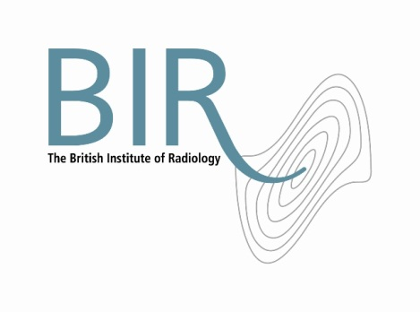

21 April 2017

**Radiobiologists are invited to apply for the**

**BIR Nic McNally Travel bursary**

£750 award for early career radiobiologists

Early career radiobiologists (scientifically or medically qualified) are invited to apply for the

BIR Nic McNally Travel Bursary which offers £750 to attend and present their work at a relevant scientific conference.

Applicants must have already had a poster or talk accepted at the conference.

The poster/talk must relate to original research in radiobiology or related subjects. The prize winner will be the individual judged to have submitted the best poster/talk abstract.

Applications will be judged by the BIR’s Awards and Prizes Committee, with advice from the BIR Oncology and Radiotherapy Special Interest Group, if required.

Both BIR members and non-members are eligible to apply.

Closing date 31 October 2017. For more information and the application form: [www.bir.org.uk/nicmcnally](http://www.bir.org.uk/nicmcnally)

The Nic McNally prize for Cancer Research was established in memory of Dr Nic McNally, previous BJR Honorary Editor and past President Elect of the BIR. The award is supported by The Gray Laboratory Cancer Research Trust.

Ends

Photo: Nic McNally

**Notes to Editors**

**About The British Institute of Radiology**

The British Institute of Radiology is an international membership organisation for everyone working in imaging, radiation oncology and the underlying sciences.

Our aims are to:

•               support the work of our members and their colleagues to achieve professional excellence

•               provide continuing professional development for our multidisciplinary community

•               publish cutting-edge research for our authors and readers across the world

•               influence and connect with the wider professional sector.

Registered Charity No: 215869

**For information about this release please contact:**

Carole Cross

Communications Manager

48-50 St John Street

London EC1M 4DG

Tel. 020 3668 2224 [carole.cross@bir.org.uk](mailto:carole.cross@bir.org.uk) [www.bir.org.uk](http://www.bir.org.uk)

Mobile 07963 200147 (out of office hours)

<https://www.facebook.com/thebritishinstituteofradiology>

<https://twitter.com/BIR_News>