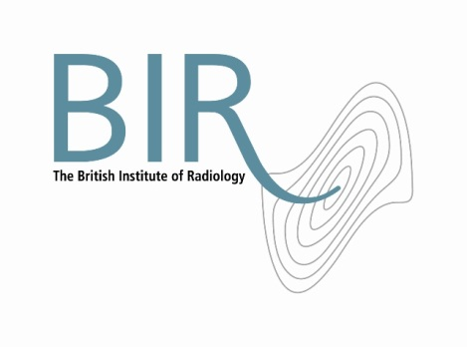

12 April 2017

**The British Institute of Radiology announces appointment of**

**new Chief Executive**

The British Institute of Radiology announces the appointment of Simon Thompson as new Chief Executive with immediate effect.

Simon will replace Jacqueline Fowler who has been Chief Executive of the BIR for the past eight years.

Simon has held senior positions in both the commercial and non-profit sectors, mainly with organisations that provide technical and educational content for specialist professionals. Among other roles he led news, data and events company IJGlobal and real-time information business DeHavilland.

Andy Rogers, President of the BIR, said “Simon brings invaluable leadership experience and skills to the BIR. Jacquie has been exceptional in how she has turned around the BIR over the last number of years, returning the BIR to a position of strength. I now look forward to working closely with Simon to take the BIR to the next stage of its development in an ever changing world”.

Simon said, “I am thrilled to be joining at such an exciting time for the BIR and our members. Through the BIR a fast growing number of people are building their expertise, developing their careers and helping to deliver better outcomes for patients”.

Ends

Image: Simon Thompson

**Notes to Editors**

**About The British Institute of Radiology**

The British Institute of Radiology is an international membership organisation for everyone working in imaging, radiation oncology and the underlying sciences.

Our aims are to:

•               support the work of our members and their colleagues to achieve professional excellence

•               provide continuing professional development for our multidisciplinary community

•               publish cutting-edge research for our authors and readers across the world

•               influence and connect with the wider professional sector.

Registered Charity No: 215869

**For information about this release please contact:**

Carole Cross

Communications Manager

48-50 St John Street

London EC1M 4DG

Tel. 020 3668 2224 [carole.cross@bir.org.uk](mailto:carole.cross@bir.org.uk) [www.bir.org.uk](http://www.bir.org.uk)

Mobile 07963 200147 (out of office hours)

<https://www.facebook.com/thebritishinstituteofradiology>

<https://twitter.com/BIR_News>