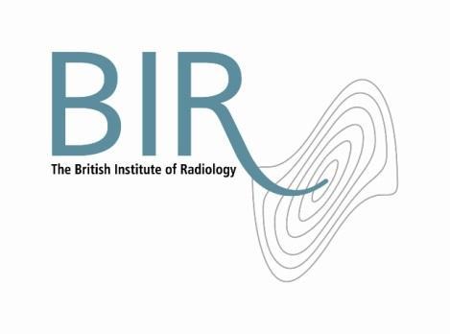

31 January 2017

**Premium Medical Protectionjoin the British Institute of Radiology**

The British Institute of Radiology (BIR) is delighted to welcome Premium Medical Protection (PMP) as a corporate member.

BIR corporate subscribers are encouraged to join the BIR community and to collaborate in educational developments and to get involved with publishing activities.

PMP is a well-established and renowned provider of quality medical indemnity insurance and is the first company of its kind to join the BIR.

Jacqueline Fowler, Chief Executive of the BIR, said “We welcome PMP to the BIR community and look forward to working with them to guide our private practice members in professional indemnity protection.”

Sharon Smith, Sales Director from PMP said “PMP looks forward to working with BIR and helping to educate all its members to navigate the complexities of medical indemnity insurance.”

Photo: (left to right) Sharon Smith, Sales Director, PMP with Jacqueline Fowler, Chief Executive, BIR.

Ends

**Notes to Editors**

**About The British Institute of Radiology**

The British Institute of Radiology is an international membership organisation for everyone working in imaging, radiation oncology and the underlying sciences.

Our aims are to:

•               support the work of our members and their colleagues to achieve professional excellence

•               provide continuing professional development for our multidisciplinary community

•               publish cutting-edge research for our authors and readers across the world

•               influence and connect with the wider professional sector.

Registered Charity No: 215869

**For information about this release please contact:**

Carole Cross

Communications Manager

48-50 St John Street

London EC1M 4DG

Tel. 020 3668 2224    [carole.cross@bir.org.uk](mailto:carole.cross@bir.org.uk)  [www.bir.org.uk](http://www.bir.org.uk)

Mobile 07963 200147 (out of office hours)

<https://www.facebook.com/thebritishinstituteofradiology>

<https://twitter.com/BIR_News>

**About Premium Medical Protection (PMP)**

PMP are the only UK Insurance broker able to provide both Claims Made and Occurrence policies.

Key Benefits:  S&P AA+ rated underwriter – Berkshire Hathaway International Insurance Ltd; multi-award winning defence lawyers, Clyde & Co; contractual cover; consent to settle; outstanding customer service – confirmed by our 97% client retention rate; 365/24-7 medical legal helpline.

Premium Medical Protection Limited are an appointed representative of Harley Street Insurance Group Limited, which is authorised and regulated by the Financial Conduct Authority FRN 570717.  Insurance is underwritten by Berkshire Hathaway International Insurance Limited, which is authorised by the Prudential Regulation Authority and regulated by the Financial Conduct Authority and the Prudential Regulation Authority.  Product availability based upon business and regulatory approval may differ. (16/11/2016)V1

**For information about this release please contact:**

Carole Cross

Communications Manager

48-50 St John Street

London EC1M 4DG

Tel. 020 3668 2224    [carole.cross@bir.org.uk](mailto:carole.cross@bir.org.uk)  [www.bir.org.uk](http://www.bir.org.uk)

Mobile 07963 200147 (out of office hours)

<https://www.facebook.com/thebritishinstituteofradiology>

<https://twitter.com/BIR_News>