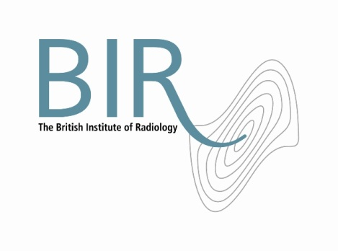

10 February 2017

**The British Institute of Radiology celebrates £2,500 gift from The Patron’s Fund**

The British Institute of Radiology is celebrating after receiving a £2,500 gift from The Patron’s Fund, the charitable fund set up to acknowledge the work of the charitable organisations for which Her Majesty The Queen acts as a Patron, on the occasion of her 90th birthday.

£750,000 was distributed between nearly 300 charities and other organisations in the UK and the Commonwealth. The Fund received generous donations from a range of supporters; including individual donors, businesses, schools, community groups and the proceeds from The Patron’s Lunch, the event on the Mall last June.

This money will help the BIR purchase a video recorder and other digital equipment to enable BIR educational events to be taped and uploaded to our members’ area so radiologists, radiographers and physicists from across the world can watch them online.

Andy Rogers, President of the BIR, said “We are thrilled with this unexpected donation which will help us to purchase useful audio-visual equipment which directly supports our members’ professional development and ultimately the patient“.

**Sir Stuart Etherington, Chair of The Board of Trustees for The Patron’s Fund, said:**

“The Patron’s Fund is very pleased to be able to support the BIR with its valuable work. The BIR is among hundreds of organisations for which The Queen acts as a Patron, which between them make a difference to communities in the UK and throughout the Commonwealth.’

Ends

**Notes to Editors**

**About The British Institute of Radiology**

The British Institute of Radiology is an international membership organisation for everyone working in imaging, radiation oncology and the underlying sciences.

Our aims are to:

•               support the work of our members and their colleagues to achieve professional excellence

•               provide continuing professional development for our multidisciplinary community

•               publish cutting-edge research for our authors and readers across the world

•               influence and connect with the wider professional sector.

Registered Charity No: 215869

**For information about this release please contact:**

Carole Cross

Communications Manager

48-50 St John Street

London EC1M 4DG

Tel. 020 3668 2224 [carole.cross@bir.org.uk](mailto:carole.cross@bir.org.uk) [www.bir.org.uk](http://www.bir.org.uk)

Mobile 07963 200147 (out of office hours)

<https://www.facebook.com/thebritishinstituteofradiology>

<https://twitter.com/BIR_News>