Dr Peter Guest : Barclay Prize 2010
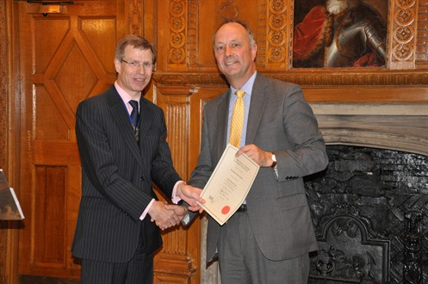
Dr Peter Guest graduated in medicine from Oxford in 1983. He obtained MRCP in 1986, FRCR in 1989 and was appointed Consultant Radiologist at the Queen Elizabeth Hospital, Edgbaston, Birmingham in 1992, where he is now Clinical Director of the Radiology Department. He is also an Honorary Senior Lecturer in Radiology at the University of Birmingham. He has a long association with the British Journal of Radiology, as an author of a number of publications in BJR and Imaging, a reviewer of numerous papers, and as Associate Editor from 2004 - 2007, and Deputy Editor from 2007 - 2010.
His breadth of knowledge and prompt returns made him one of our most hard-working and popular members of the Editorial Board, as he was able to assess papers in such a wide range of topics including US, CT, fluoroscopy, MRI, radionuclide imaging and PET CT, in the fields of oncology, gastrointestinal, renal/urology, thoracic and cardiac imaging. In these days of increasing subspecialisation, few could rival his contribution.
He is therefore a well deserving nominee for the Barclay Prize.

