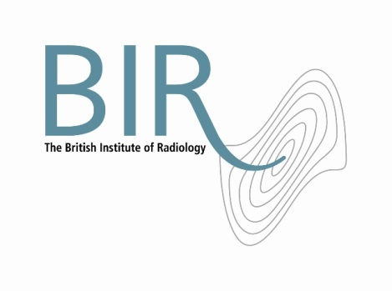

**Role Description**

**Honorary Treasurer – The British Institute of Radiology**

Eligibility and term of office

The Treasurer shall be a trustee of the Institute.

The Treasurer shall be appointed for a term of three years, beginning from 1 October. At the end of his or her term, and unlike other Officers, the Treasurer may apply to be considered for appointment for a second term.

Overall purpose

The Treasurer is the principal financial Officer of the Institute and is responsible to Council. S/he shall deal with the financial affairs of the Institute and shall be responsible for ensuring the accounts of the Institute are kept in accordance with the requirements of the Charity Commission and in accordance with all appropriate financial reporting arrangements.

Despite the additional responsibility the Treasurer has in overseeing the financial matters of the Institute, all trustees continue to be jointly and severally responsible, and therefore liable, for the administration of the charity.

In addition to the general responsibilities of a trustee, the Treasurer has a number of responsibilities specific to his/her role.

Main responsibilities

* To oversee and present budgets, management accounts and financial statements to the Council of trustees.
* To ensure that proper accounts and records are kept, ensuring financial resources are spent and invested in line with the Institute’s policies, good governance, legal and regulatory requirements.
* To be instrumental in the development and implementation of financial, reserves and investment policies.
* To report on risk management and ensure that the implementation and monitoring of specific financial controls and systems are in place and adhered to.
* To advise on the financial impact of policies and proposals from Council.

The Treasurer reports to the Annual General Meeting on the accounts of the Institute and prepares the financial section of the annual report.

As a trustee of the Institute and member of Council, the Treasurer is expected to play a full part in the governance of the Institute as a charity registered with the Charity Commission.

Terms and conditions

The Treasurer is required to attend the following meetings:

* Council (four per annum)
* Audit & Investment Committees (to chair a maximum of three each per annum)
* Annual General Meeting

In addition, the Treasurer may be requested to attend ad hoc working parties and may be asked to represent the BIR on external bodies where a financial or governance aspect arises or where another Officer is unable to attend.

This is a voluntary post and is therefore unremunerated. Travel and subsistence expenses will be paid in line with the Institute’s T&S policy.

Staff support

The Treasurer is supported and advised by the Finance & Operations Manager, one of the Institute’s senior managers.

May 2012