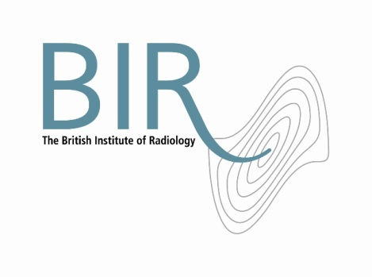

**Role Description**

**Honorary Secretary – The British Institute of Radiology**

Eligibility and term of office

The Honorary Secretary shall be a trustee of the Institute. S/he shall be appointed for a term of three years, beginning from 1 October.

Role responsibilities

In addition to the general responsibilities of an ordinary trustee, the role of the Honorary Secretary has the following duties:

**Member engagement**

* To take trustee lead on the strategic development of branches/regions.
* To provide oversight and management of the scientific committees/special interest groups (SIGs), ensuring effective control of scientific direction, subject coverage and inter SIG collaboration.
* To ensure the SIGs, via active membership engagement, operate in line with strategies for education, publishing and external engagement.
* To liaise with the VP for External Affairs to advise on appropriate BIR member expertise for consultations.

**Governance**

* To provide trustee leadership for the organisation’s audit procedures and act as chair the Institute’s Audit Committee.
* To lead on the interpretation and updating of the BIR’s Charter and bylaws.
* To coordinate the advertising of trustee vacancies and manage relevant elections in accordance with the bylaws.
* To advise on the organisation of the AGM and relevant EGMs/SGMs.

Terms and conditions

The time commitment associated with this role will be in the region of two days per month.

This is a voluntary post and is therefore unremunerated. Travel and subsistence expenses will be paid in line with the Institute’s T&S policy.

May 2014