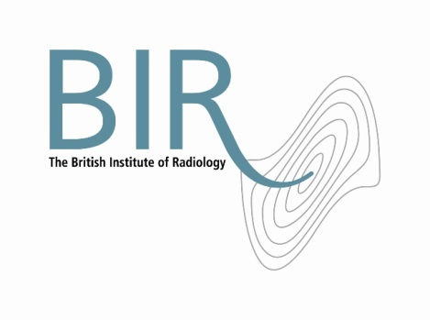

**Role Description**

**President – The British Institute of Radiology**

The President shall be a trustee of the Institute and would be elected by the Council of trustees, and would normally be filled by a trustee who had previously undertaken a Vice President role. The appointment is for a term of two years, beginning from 1 October, and would normally alternate between medical and scientific disciplines.

Purpose

The role of the President is to provide leadership and direction to the Council of trustees. The aim is to enable the trustees to fulfil their responsibilities for the overall governance and strategic direction of the Institute.

The President will ensure that the organisation complies with its governing document, charity law and any other relevant legislation or regulations and to make sure that the Institute pursues its objects as defined in its governing document.

The President’s role is also to work in partnership with the Chief Executive to achieve the mission of the organisation and to develop a strategic balance in the relationships between the Council, staff and members.

In addition to the general responsibilities of a trustee, the President has a number of responsibilities specific to his/her role.

Main responsibilities

* To chair Council so that it discharges its duties effectively, and in particular setting and monitoring strategy and policy objectives, and encouraging full participation by attendees.
* To ensure the proper governance of the Institute such that it fulfils its legal, financial and regulatory responsibilities.
* To serve as a spokesperson for the Institute and represent it at appropriate conferences, meetings or functions.
* To ensure that Council and the Chief Executive deliver a long term strategy for the organisation with objectives that can be monitored and appraised.
* To monitor and review the work of the Chief Executive and to support the Chief Executive and the management team.
* To meet regularly with the Chief Executive.

Person specification

* Full member of the BIR for at least five years with previous experience of chairing committees and/or of serving on Council at the BIR.
* Knowledge, gained through experience, of the field of radiology and radiation oncology.
* Knowledge and experience of the NHS and medical communities.
* Ability to grasp a strategic vision and to give passionate leadership to its execution.
* Extensive relevant contacts and willingness to use them for the benefit of the BIR.
* A successful track record of chairing meetings, ensuring all members are included, achieving consensus and clarity of outcomes.

Personal style, skills and characteristics

* A diplomat and ambassador, an effective high-level networker and a strong advocate for the British Institute of Radiology.
* A respected figure in the field of radiology.
* An ability to articulate the mission, vision and strategy of the BIR to key stakeholders.
* An ability to communicate with businesses, the media and stakeholders in order to promote the work of the BIR effectively.
* An ability to engage with a range of audiences including members, companies, sister societies, etc.
* An appreciation of the responsibilities of charity trustees, charity law and the principles of charity governance.
* An understanding of the distinction between governance and management.
* An able public speaker with presence, media, communication and interpersonal skills.
* The ability to provide leadership to the organisation and enthusiasm for its aims.

Terms and conditions

The time commitment associated with this role will be in the region of 2-4 days per month attendance in London. In addition, other contact – usually electronic or by telephone – will be necessary.

The President is advised by the Chief Executive and has administrative support from the BIR.

This is a voluntary post and is therefore unremunerated. Travel and subsistence expenses will be paid in line with the Institute’s T&S policy.

May 2012