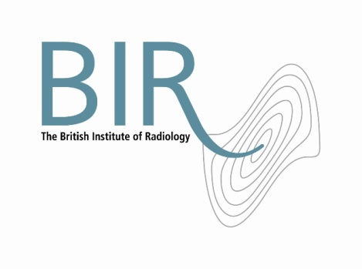

**Role Description**

**Vice President – The British Institute of Radiology**

Eligibility and term of office

There are three Vice President roles, each one on a specific key area of the Institute’s strategy: education, publications and external affairs.

The Vice Presidents shall be trustees of the Institute. The appointment is for a term of three years, beginning from 1 October. Normally the roles would alternate between members of medical and scientific disciplines and at any one time there should be a mix of medical and scientific.

Role: general responsibilities

In addition to the general responsibilities of an ordinary trustee, the Vice President has the following duties:

* Chair meetings of the Council in the absence of the President.
* Represent the BIR at functions, meetings or external committees and act as an ambassador and/or spokesperson as appropriate.
* Deputise for the President at functions the President would normally cover when s/he is not available.
* Undertake special assignments as the request of the President.
* Provide support as appropriate to the chairs of the scientific committees/special interest groups.
* Act as a first-call spokesperson on BIR matters where a senior trustee is required to deal with the media.

Specific responsibilities

Each Vice President will also be responsible for their specific key area: education, publications and external affairs. Within these remits each will:

* Chair the relevant committee and ensure that committee members fulfil their responsibilities for the subject area.
* Lead on the development of the subject area’s strategy in partnership with the relevant senior staff member.
* Ensure that the subject area’s business plan is delivered with objectives that can be monitored and appraised.
* Participate in other tasks that arise from time to time, such as interviewing for senior posts within the organisation.

Terms and conditions

The time commitment associated with this role will be in the region of 1-2 days per month. In addition, other contact – usually electronic or by telephone – will be necessary.

This is a voluntary post and therefore unremunerated. Travel and subsistence expenses will be paid in line with the Institute’s T&S policy.

May 2013