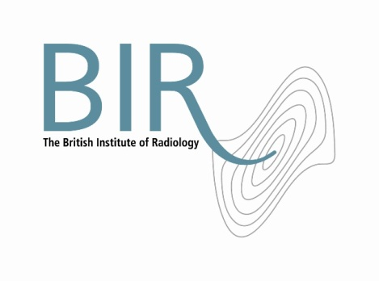

19 January 2015

**PRESS STATEMENT**

**The British Institute of Radiology Response to Increase in**

**Cancer Drugs Funding to £340m**

The BIR welcomes the increase in cancer drugs funding to an estimated £340m, following the outcome of the NHS Cancer Drugs Fund review on 12 January 2015.

However, funding for advanced radiotherapy techniques falls far behind that of chemotherapy when radiotherapy cures more patients than chemotherapy alone. Second only to cancer surgery, radiotherapy is involved in 40 per cent of cases where cancer is cured. It is estimated that radiotherapy is the primary treatment used in 16% of patients who are cured of their cancer. By comparison, chemotherapy is the primary modality in only 2%.[1]

The BIR calls for an increase in radiotherapy funding alongside complex chemotherapy drugs.

Ends

**Notes to Editors**

**About The British Institute of Radiology**

* The British Institute of Radiology (BIR) is an independent multidisciplinary organisation, and a registered charity, whose membership is open to everyone with an interest in radiology and radiation oncology.
* The British Institute of Radiology is the oldest radiological society in the world.
* We strive to ensure that the potential of image science and radiation technology to prevent, detect and combat disease is fully realised. We believe in the importance of research and education, and we promote collaboration and the sharing of knowledge and understanding.
* To help fulfil our aims, we undertake a wide range of activities, including publishing, the organisation of scientific meetings and conferences and the provision of library and information services.

Registered Charity No: 215869

**For information about this release please contact:**

Carole Cross

Communications Manager

48-50 St John Street

London EC1M 4DG

Tel. 020 3668 2224 [carole.cross@bir.org.uk](mailto:carole.cross@bir.org.uk) [www.bir.org.uk](http://www.bir.org.uk)

<https://www.facebook.com/thebritishinstituteofradiology>

<https://twitter.com/BIR_News>

1. Einhorn J et al 1996 Radiotherapy for Cancer, vol 1. Acta oncologica 35 (supp 6) 1-100 and (supp 7) 1-152

   IAEA 2010 - Planning National Radiotherapy Services: A Practical Tool. http://www.iaea.org