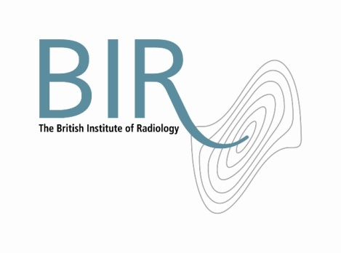
31 October 2014
PRESS RELEASE

Professor Ignac Fogelman receives Sir Godfrey Hounsfield Memorial Award

On 23rd October, at the BIR Annual Congress, at the Royal College of General Practitioners, Professor Ignac Fogelman was awarded the prestigious Sir Godfrey Hounsfield Memorial Award, following delivery of a lecture entitled “The Isotope Bone Scan: Past, Present and Future.” He was presented with the award by President of the BIR, Dr David Wilson.

Professor Fogelman is Professor of Nuclear Medicine (NM) at King’s College London and Honorary Consultant Physician at Guy’s and St Thomas’ NHS Trust and Director of the Osteoporosis Screening and Research Unit, Guy’s Hospital.

Professor Fogelman said “I am truly honoured to receive this award and to be associated with the eminent Sir Godfrey Hounsfield, to whom all professionals working in medical imaging today, owe so much.”

Professor Fogelman is chairman of the board of examiners for the MSc in Nuclear Medicine at King’s College which provides the only recognised training programme for nuclear medicine in the UK. He has published over 400 articles in peer reviewed journals, has written or edited 15 books and supervised 17 PhD/MD students. He is a former board member and trustee of the National Osteoporosis Society and was previously chairman of its Bone Densitometry (BD) Forum.
This award was established in 1977 in honour of Sir Godfrey Hounsfield and his pioneering work in computed tomography (CT). The lecture was initially endowed by Dr Marion Frank OBE, and subsequently funded from a bequest from Sir Godfrey Hounsfield.

Ends

Notes to Editors
About The British Institute of Radiology

- The British Institute of Radiology (BIR) is an independent multidisciplinary organisation, and a registered charity, whose membership is open to everyone with an interest in radiology and radiation oncology.

- The British Institute of Radiology is the oldest radiological society in the world.

- We strive to ensure that the potential of image science and radiation technology to prevent, detect and combat disease is fully realised. We believe in the importance of research and education, and we promote collaboration and the sharing of knowledge and understanding.

- To help fulfil our aims, we undertake a wide range of activities, including publishing, the organisation of scientific meetings and conferences and the provision of library and information services.

Registered Charity No: 215869

For information about this release please contact:

Carole Cross
Communications Manager
48-50 St John Street
London EC1M 4DG
Tel. 020 3668 2224 carole.cross@bir.org.uk www.bir.org.uk

